**DOCUMENTATION FOR RADIANT DICOM VIEWER**

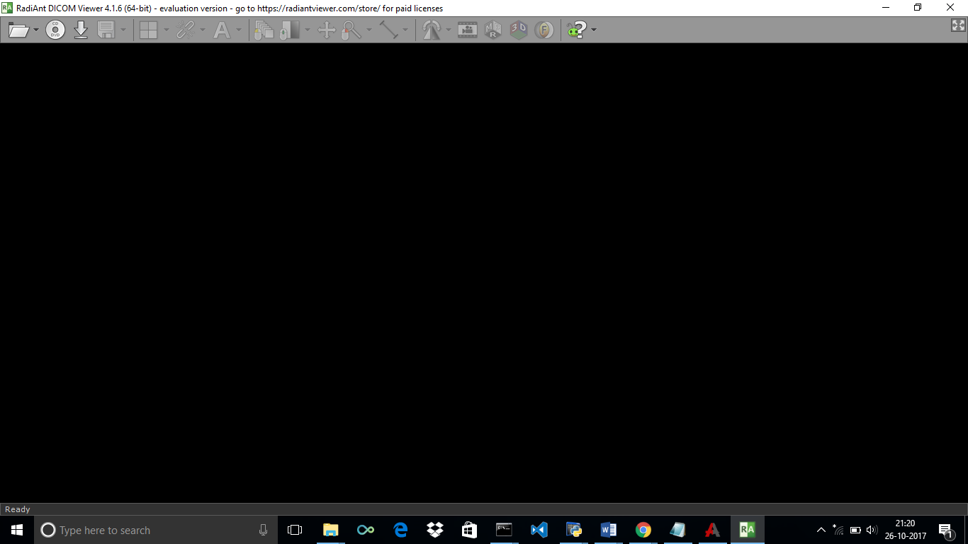

**RADIANT DICOM VIEWER**

**Various Options occurs like Dicom Folder,Open Dicom file or Zip file. Select the one.**

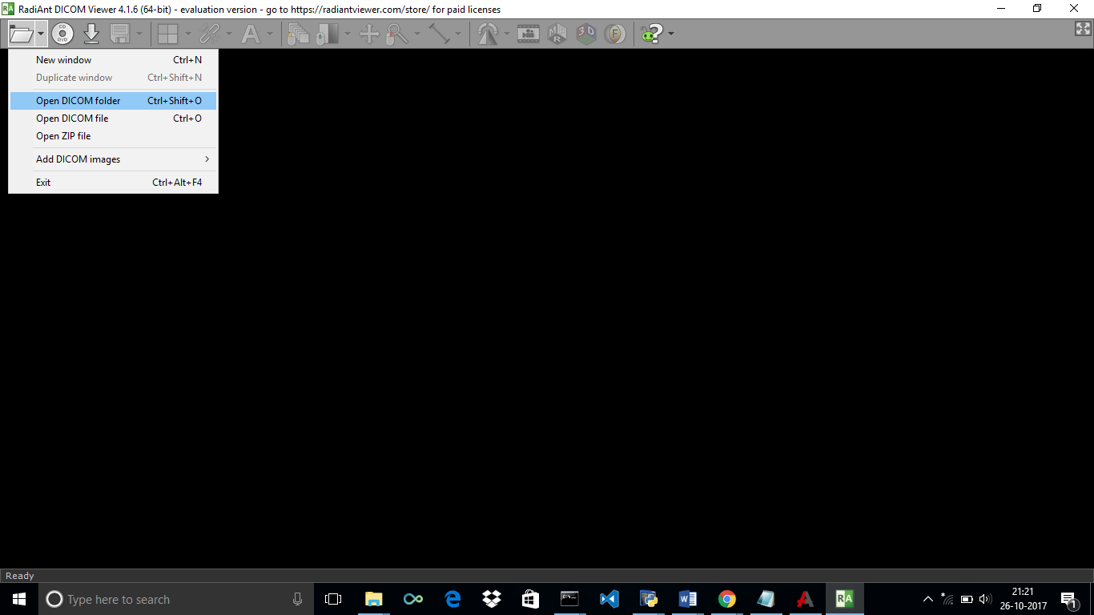

Browse the file to View.

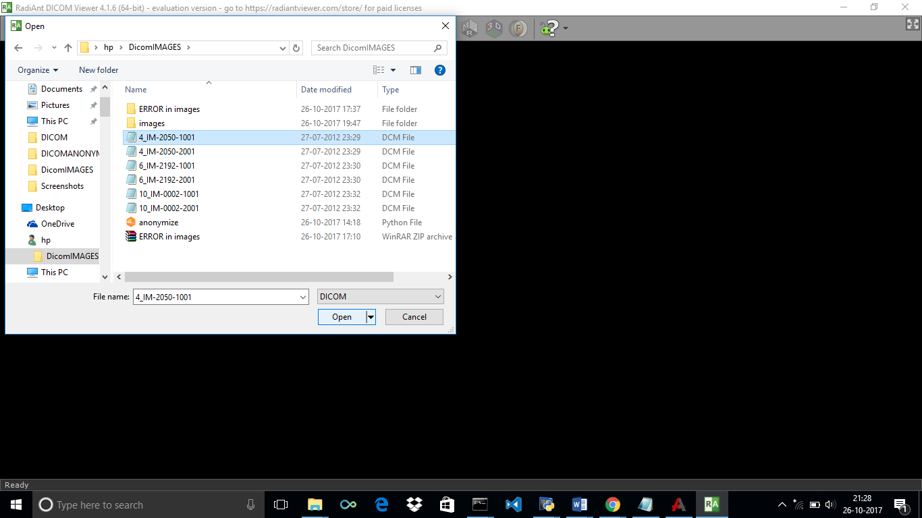

**View the Image.**

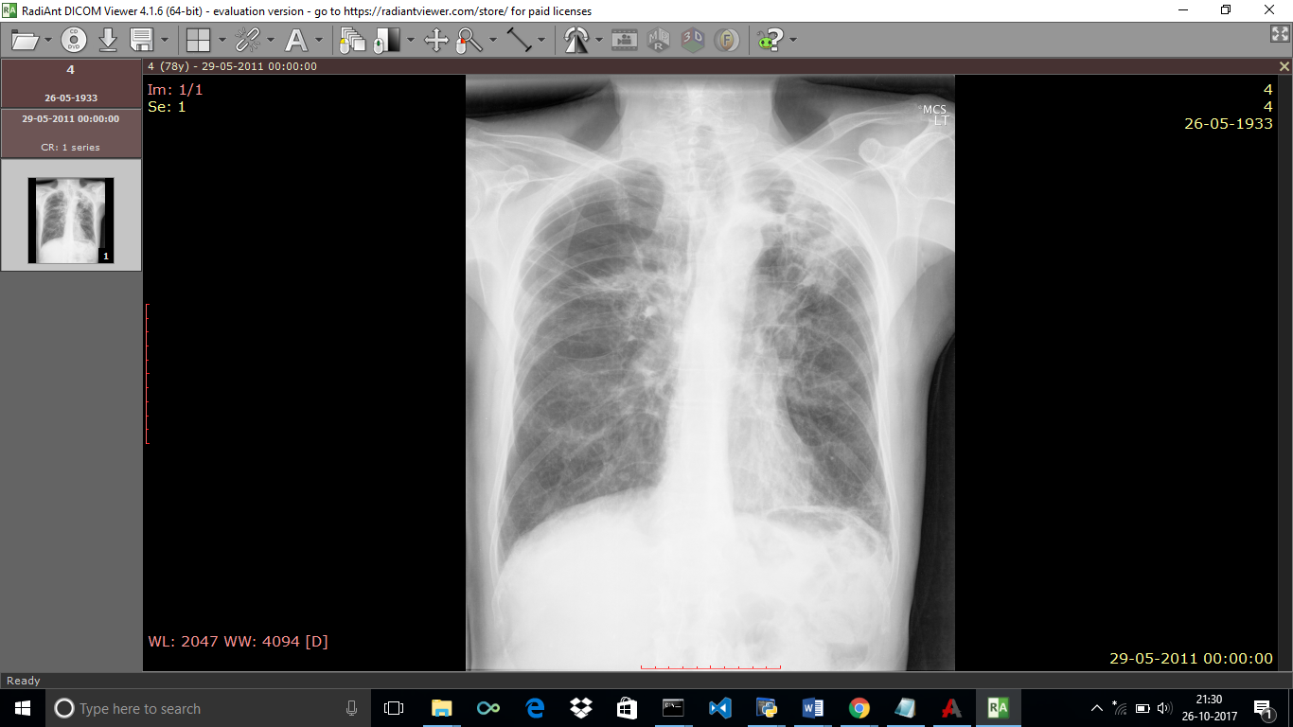**2**

**Zoom it and view the X and Y axis and other things.**

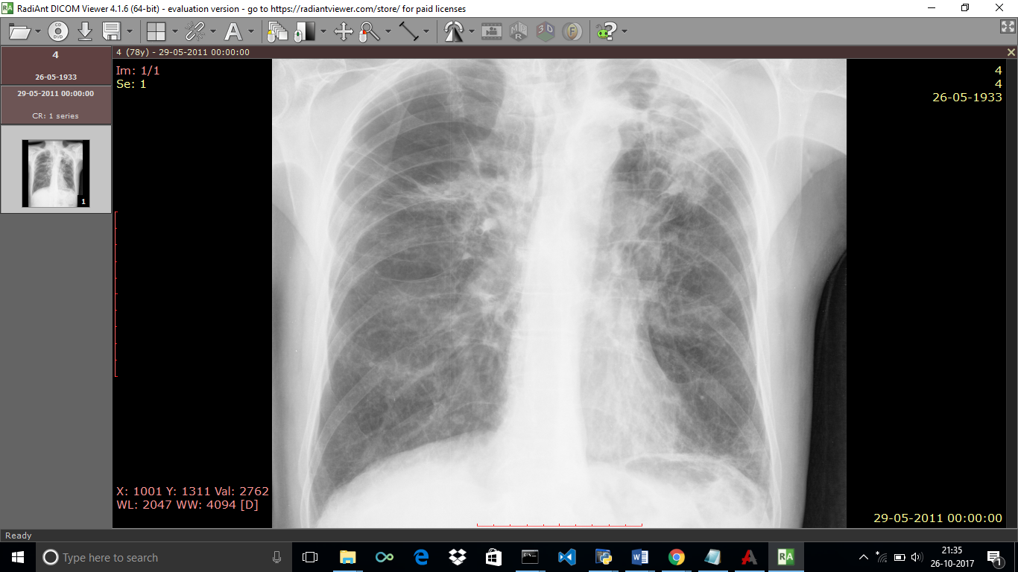

**Viewing multiple images in Folder-**

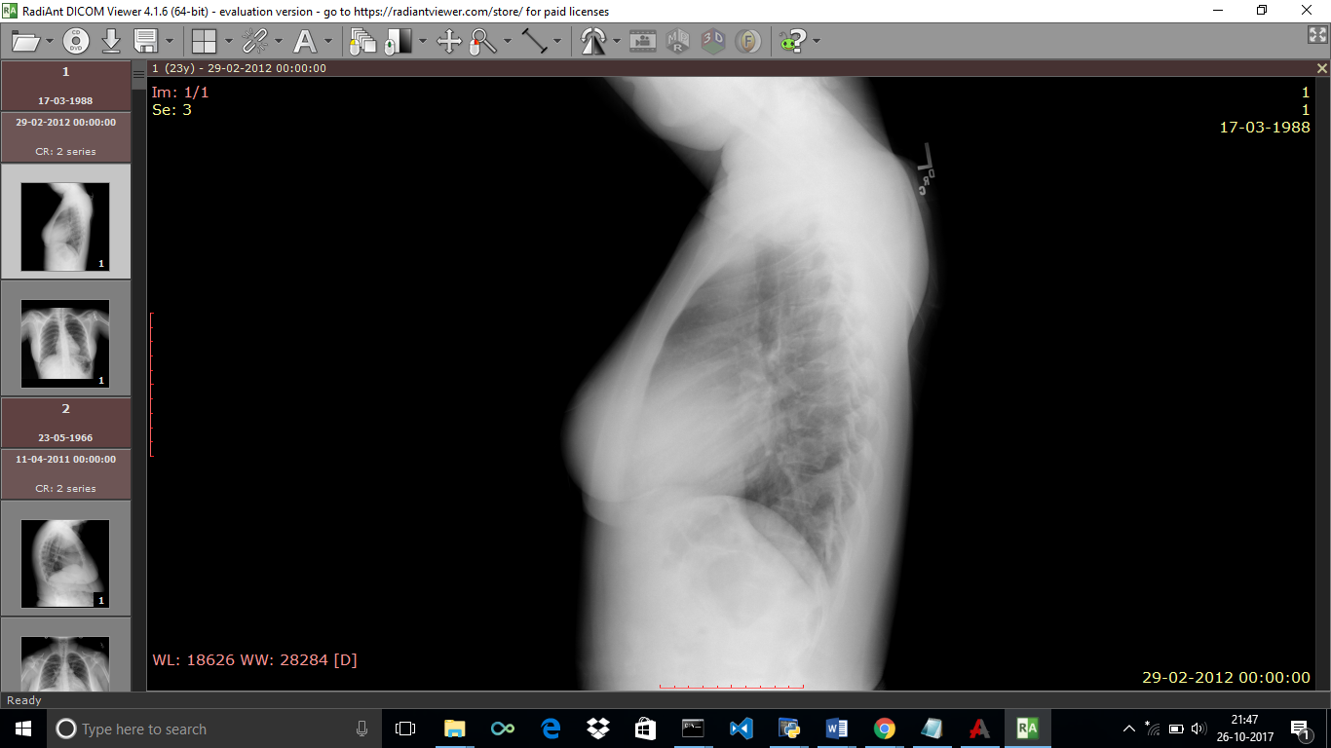

**View files in the selected folder.**

**The images are displayed in the left.**

**Select the image to View it.**

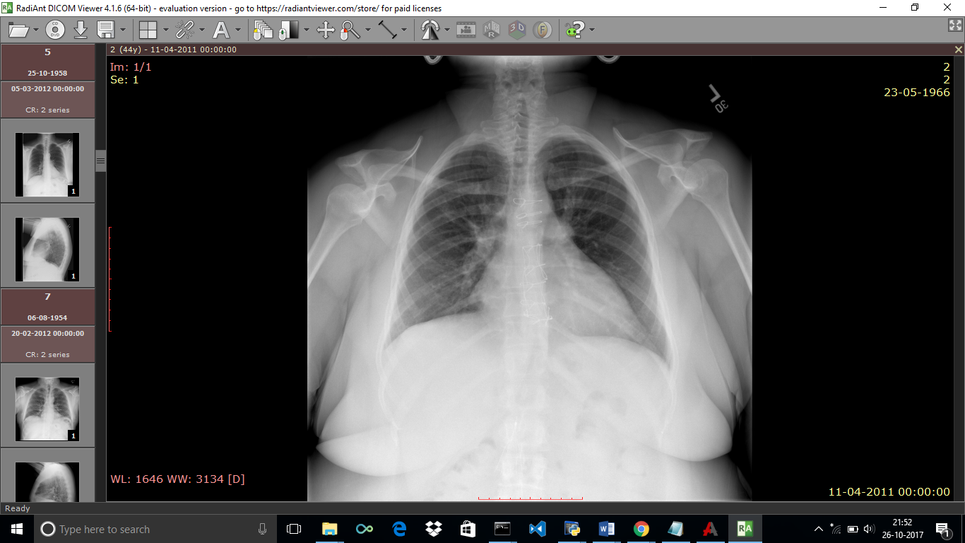

**----------------------------------END--------------------------------------**